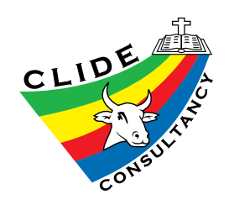
Mission Aviation Fellowship (MAF)
Request for Flight Booking

Please fill, save, and e-mail this form one month prior to your trip.
Send to:
Dr. Moses Otim: vet.mission4christ@gmail.com

Passenger Information:
- Passenger name: Click here to enter text.
- Weight of passenger (in kilograms): Click here to enter text.

Flight Information:
- Date flight requested for: Click here to enter a date.
  - Departing from: Choose an item.
  - Arriving to: Choose an item.
- One way or Round trip
- Return flight date (if known): Click here to enter a date.
  - Departing from: Choose an item.
  - Arriving to: Choose an item.

Luggage Information:
- Are you carrying more than the allowed 15kg (33lbs) of luggage? Choose an item.
- If yes, enter the weight of excess luggage to be booked: Click here to enter text.

Included in your fare is a total of 15kg (33lbs) for your hand luggage and checked-in luggage. Booked, excess luggage will cost $2 per kilo. Unbooked, excess baggage can be carried at $4 per kilo, subject to availability of space.
(NB: some excess luggage, especially those brought for CLIDE or Lomilos, may remain in Kampala and be shipped or picked up later)

Important Information:
- Confirmation of your flight booking is subject to MAF approval.
- Payment for flight is the responsibility of the passenger.
- MAF’s operations are outside of the control of CLIDE, therefore CLIDE accepts no responsibility or liability for passenger or luggage safety during MAF flights or flight scheduling and availability.
- Please carefully review MAF’s Terms and Conditions available on their website (maf-uganda.org) for airfield arrival times, flight pricing, etc.

